Right of Way Acceptable Delivered Data
This is a guide to formats for acceptable data from consultants for use in the Right of Way Tool.

This document will elaborate on the data requirements outlined in the Project Work Plan as:
- Proposed ROW polygons will be prepared in Microstation DGN format based on express designs. The polygons will distinguish control of access type and whether the footprint is on existing or new location. Following data transfer, conversion to a GIS shapefile for processing with the ROW calculation tool will be considered part of the AECOM ROW support workflow.
- PDF maps of the express designs will be provided that clearly illustrate the project alternatives.
- Any editing or cleanup deemed necessary beyond normal data processing will be considered additional work and charged as part of workflow efforts. Excessive data manipulation required to process data may require additional editing by the source consultant. In such cases, AECOM will consider transmittal and coordination of this data as part of workflow efforts.
- The source consultant will also provide the right of way request form, describing the alternatives that will be submitted for the traditional right of way request and including the anticipated level of utility impacts (low, medium or high).

Definition of Terms
Alternate: a section of right of way which occupies the same location as another section of right of way, of which only one is intended to be constructed.

Section: A subset of the total right of way required for the project intended to be completed in conjunction with other sections.

Level of Control of Access: NCDOT identifies four levels of control of access.
- Full Control of Access: Connections to a facility provided only via ramps at interchanges. All cross-streets are grade-separated. No private driveway connections allowed. A control of access fence is placed along the entire length of the facility and at a minimum of 1000 feet beyond the ramp intersections on the Y lines (minor facility) at interchanges (if possible).

- Limited Control of Access: Connections to a facility provided only via ramps at interchanges (major crossings) and at-grade intersections (minor crossings and service roads). No private driveway connections allowed. A control of access fence is placed along the entire length of the facility, except at intersections, and at a minimum of 1000 feet beyond the ramp intersections on the Y lines (minor facility) at interchanges (if possible).

- Partial Control of Access: Connections to a facility provided via ramps at interchanges, at-grade intersections, and private driveways. Private driveway connections are normally defined as a maximum of one connection per parcel. One connection is defined as one ingress and one egress point. The use of shared or consolidated connections is highly encouraged. Connections may be restricted or prohibited if alternate access is available through other adjacent public facilities. A control of access fence is placed along the entire length of the facility, except at intersections and driveways, and at a minimum of 1000 feet beyond the ramp terminals on the minor facility at interchanges (if possible).

- No Control of Access: Connections to a facility provided via ramps at interchanges, at-grade intersections, and private driveways. No physical restrictions, i.e., a control of access fence, exist. Normally, private driveway connections are defined as one connection per parcel. Additional connections may be considered if they are justified and if such connections do not negatively impact traffic operations and public safety.

Existing Roadway: Right of way acquisition is along (or primarily along) an existing road facility.

New Roadway: Right of way acquisition is along a rout (or primarily along a route) where there is not currently a road facility.

Acceptable Geometries
The right of way tool requires a closed polygon to accurately analyze the impacts to parcels. Ideally, this should take the form of a single polygon that includes both the existing and proposed right of way in the project area for each unique set of sections, alternates, levels of control of access and new/existing roadways. Several polygons representing only the new sections of right of way are less ideal, but can work with the right of way tool, however, the potential for differences between the geometry of the delivered polygon and the source parcels could result in calculation errors.

Best:

OK:
No:

Distinguishing between levels of control of access, new/existing roadway, alternatives or sections

Control of Access
The best way to distinguish levels of control of access is in the DGN’s layer properties. In the NCDOT model the “Control of Access” layer will be assumed to be “Full” or “Limited” control of access and the “Right of Way” layer will be assumed to be “Partial” or “No” control of access. Other layers can be used, but should be accompanied with a description of what the level of control of access is for each layer used.

New/Existing Roadway
This should be visible from examining the right of way with current maps or aerial imagery, however distinguishing this through separate polygons, with different levels, layers, line weights or colors, will make it easier for us.
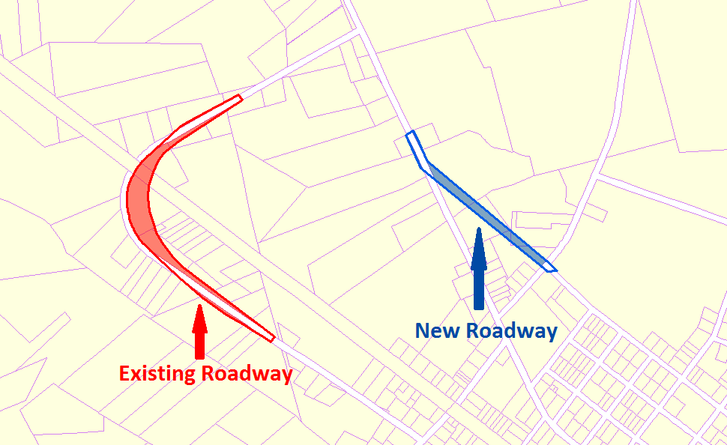
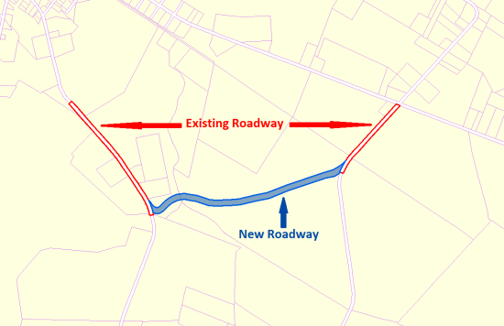

Sections or Alternatives
NAD_1983_StatePlane_North_Carolina_FIPS_3200_Feet
WKID: 2264 Authority: EPSG

Projection: Lambert_Conformal_Conic
False_Easting: 2000000.002616666
False_Northing: 0.0
Central_Meridian: -79.0
Standard_Parallel_1: 34.33333333333334
Standard_Parallel_2: 36.16666666666666
Latitude_Of_Origin: 33.75
Linear Unit: Foot_US (0.3048006096012192)

Geographic Coordinate System: GCS_North_American_1983
Angular Unit: Degree (0.0174532925199433)
Prime Meridian: Greenwich (0.0)
Datum: D_North_American_1983
Spheroid: GRS_1980
Semimajor Axis: 6378137.0
Semiminor Axis: 6356752.314140356
Inverse Flattening: 298.257222101
The best way to distinguish between different sections or alternatives is to deliver them as separate DGNs.

Geographic Projection
DGNs should be created in North Carolina State Plane in the North American Datum 1983. If no projection information is transmitted, it will be assumed that this is the correct projection.

